Game Design Document

Fill up the following document

1. Write the title of your project.

Indian Army Commando

1. What is the goal of the game?

The goal of the game is to blast the helicopters in the sky with a weapon and also avoid the log obstacles that fall from the helicopters.

1. Write a brief story of your game.

You are a soldier of the Indian Army. The Pakistani Army is dropping log obstacles via helicopters in Kashmir. Blast all the helicopters with a weapon and also avoid the log obstacles falling from the helicopters. If you blast the helicopters the Indian Army will be victorious or else the Pakistani Army will capture parts of Kashmir.

1. Which are the playing characters of this game?

* Playing characters are the ones who respond to the user based on the input from the user.
* Cars, monkeys, dinos, wizards, etc., are the playing characters in the game.

|  |  |  |
| --- | --- | --- |
| Number | Character Name | What can this character do? |
| 1 | Soldier(Player) | Shoots bullets towards the helicopters, jumps over the log obstacles |
| 2 | Gun | Weapon by which Player shoots bullets towards the helicopters. |
| 3 |  |  |
| 4 |  |  |
| 5 |  |  |
| 6 |  |  |
| 7 |  |  |
| 8 |  |  |

1. Which are the Non-Playing Characters of this game?

* Non-Playing characters are the ones that don't have an action or behavior when the user interacts with the game.
* Hurdles, stones, bananas, coins, etc., are non-playing characters in the game.

|  |  |  |
| --- | --- | --- |
| Number | Character Name | What can this character do? |
| 1 | Wooden Logs | They drop from the helicopters on the ground and act as an obstacle for the soldier. |
| 2 | Helicopters | Drop logs on the ground |
| 3 |  |  |
| 4 |  |  |
| 5 |  |  |
| 6 |  |  |
| 7 |  |  |
| 8 |  |  |

Draw your imagination of this game. What does this game look like?

* Draw the game either on your computer or on paper.
* Add images of the game scenes to show each of the playing and non-playing characters at least once.

See next page for images of my game!!!!

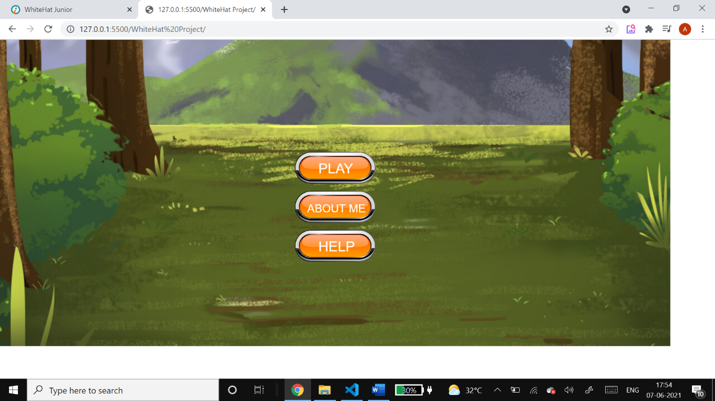 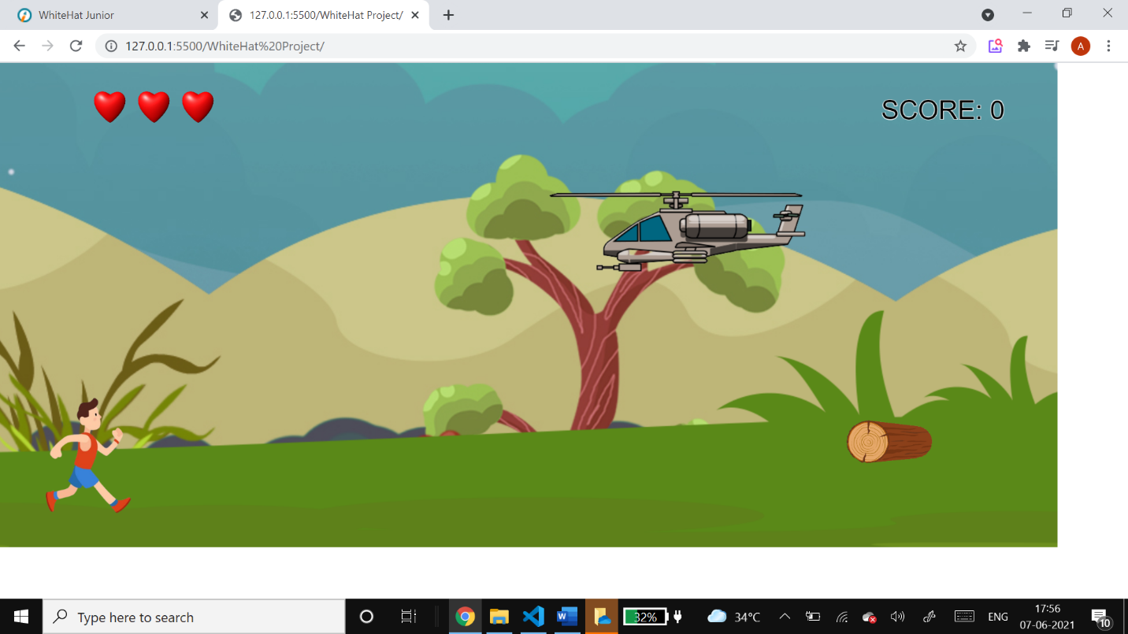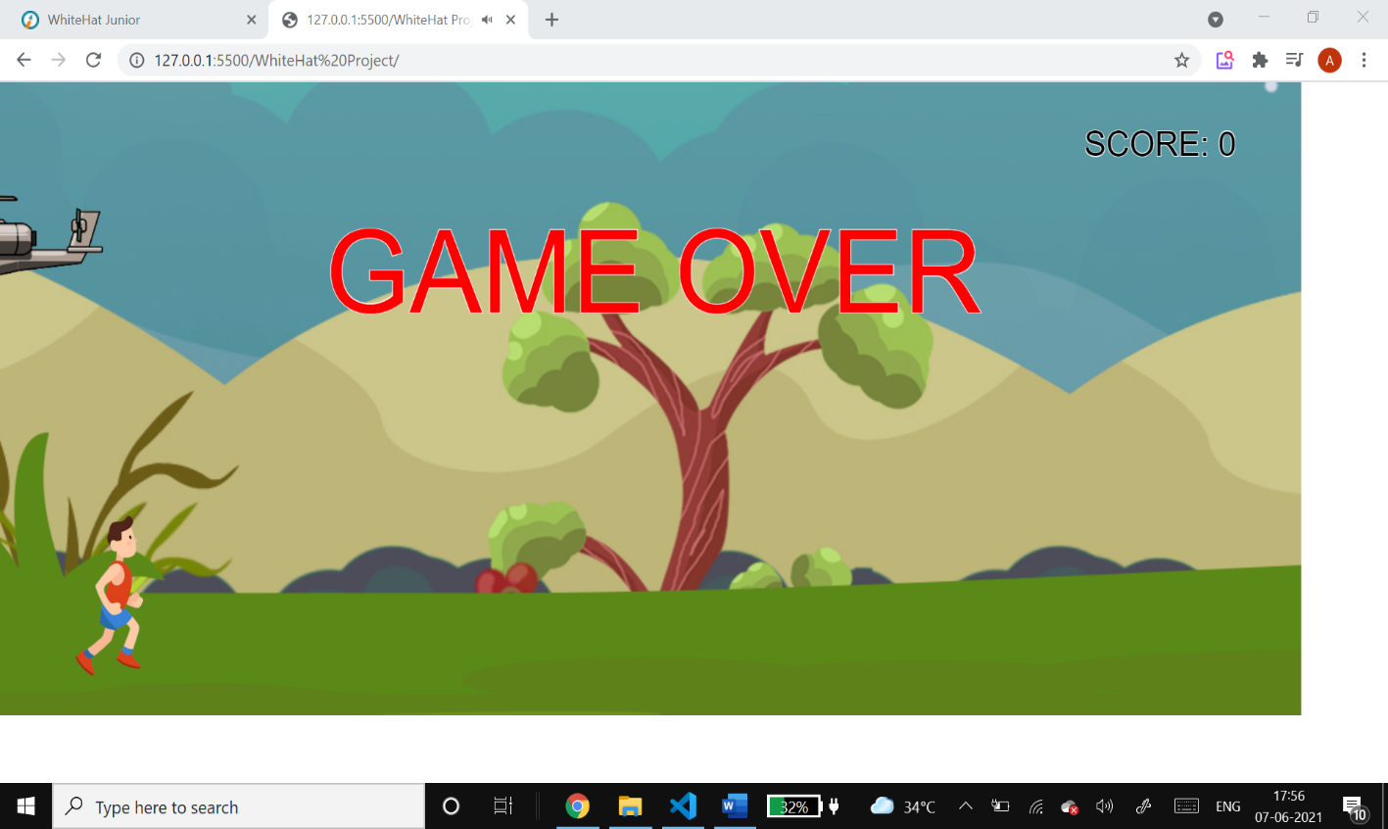

How do you plan to make your game engaging?

I am making my game engaging by rewarding the army player with rewards such as gold coins which drop in between the game